Thank you for your enquiry about joining Mensa and IQ testing.

Mensa is a round table society, meaning all members are equal. The only criterion for membership of Mensa is an IQ measured in the top two per cent of the population.

Prospective members must offer evidence that they have been assessed by a recognised process and that they are in the top two percent of the population. If that is done successfully they are invited to join. Evidence of their IQ can be through a full educational psychologist's report, documentary evidence of previous IQ testing, or by sitting an approved supervised IQ test, offered by various organisations.

In order for your application supported by ‘prior evidence’ to be processed you will need to complete the enclosed form and return it to us, along with a copy of your evidence (e.g. full psychologist's report or test papers - we advise you send only photocopies, not originals) and the ratification fee of £9.50. Once eligibility of the evidence has been confirmed, Mensa will be able to issue an invitation to join.

If you have any questions about the process, please feel free to contact me by email at helen@mensa.org.uk or telephone 01902 772771.

Yours sincerely
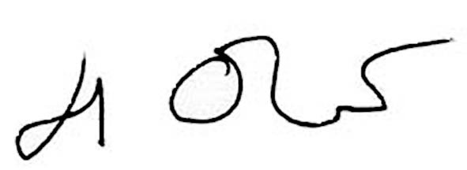
Helen Oliver
Testing and Admissions Co-ordinator

Enc.

Prior Evidence for Membership Application

Please complete by using BLOCK CAPITALS

I wish to submit prior evidence to support my application to join British Mensa Ltd

Mr/Mrs/Miss/Ms (delete as applicable) SURNAME

FORENAMES

ADDRESS:

POSTCODE:
OCCUPATION
DATE OF BIRTH
TELEPHONE (HOME) (WORK)
E-MAIL

I enclose:

Evidence of previous IQ testing – please send photocopies of reports or certificates

Test Administered by ...........................................................................................
and I confirm that they are not related to the candidate in anyway.

Ratification fee of £9.50 (€12.00)

Please make cheques/postal orders payable to British Mensa Ltd

DO NOT SEND BANK NOTES. This fee is non-refundable

I enclose a cheque for £9.50 (€12.00)  payable to British Mensa Ltd. |  |  | Tick | OR . . . Please debit the sum of £9.50  from my credit/debit card |  |  | Tick
I wish to pay by VISA / MASTERCARD / MAESTRO / VISA DEBIT / VISA ELECTRON (please circle)
Card number :
Name on Card |  |  |  | Start Date |  | Expiry Date
Card Verification Code  (the 3 or 4 digit code printed on the signature strip on the back of your card) |  |  |  |  | Issue number  (debit cards)
Signature |  |  |  | Date
Address (if different from above)

I confirm that all information given above is correct and that I am a permanent resident in the British Isles or Republic of Ireland and I have not previously been a member of any other National Mensa.

Signed …………………………………………… Date …………………

Applicants aged 16 or under will need their application counter-signed by a parent or legal guardian.

Parent/Guardian ………………………..……… Date …………………

Please return completed form to: British Mensa Ltd, St John’s House, St John’s Square, Wolverhampton, WV2 4AH

